AN ORDINANCE AMENDING THE CITY OF HIGH POINT DEVELOPMENT ORDINANCE

WHEREAS, the City of High Point adopted the “City of High Point Development Ordinance” on May 16, 2016, with an effective date of January 1, 2017, and subsequently amended; and

WHEREAS, public hearings were held before the Planning and Zoning Commission on April 25, 2023 and before the City Council on May 15, 2023 regarding Text Amendment 23-02; and

WHEREAS, notice of the public hearings was published in the High Point Enterprise on April 15, 2023 for the Planning and Zoning Commission public hearing, and on May 3, 2023 and May 10, 2023 for the City Council public hearing pursuant to Chapter 160D-601 of the General Statutes of North Carolina.

NOW THEREFORE, BE IT ORDAINED BY THE CITY COUNCIL OF THE CITY OF HIGH POINT, NORTH CAROLINA:

SECTION 1.
(Regarding changes to applications for conditional zoning or planned development requests)

PART A.
That Section 2.4.6.B.8. Changes to Application, regarding changes made by applicants for conditional zoning applications, is hereby amended as follows:

(a) Changes shall be made in writing to the Planning and Development Director during or after the hearing conducted by the P&Z but no closer two than 8 business days prior to final action by the City Council on the conditional zoning application;
(b) (unchanged)
(c) (unchanged)

PART B.
That Section 2.4.9.B.8. Changes to Application, regarding changes made by applicants for planned development applications, is hereby amended as follows:

(a) Changes shall be made in writing to the Planning and Development Director during or after the hearing conducted by the P&Z but no closer than 48 hours 8 business days prior to final action by the City Council on the planned development application;
(b) (unchanged)
(c) (unchanged)

SECTION 2.
(Regarding the Variance procedure)
That Section 2.4.16. Variance, is hereby amended as shown, to reflect the current variance procedure. It was previously included in TA-20-03, related to watershed protection standards, but erroneously amended again with TA-21-01 during previous amendments related to 160D.

(Replace the existing Variance Procedure flowchart with this new version below)
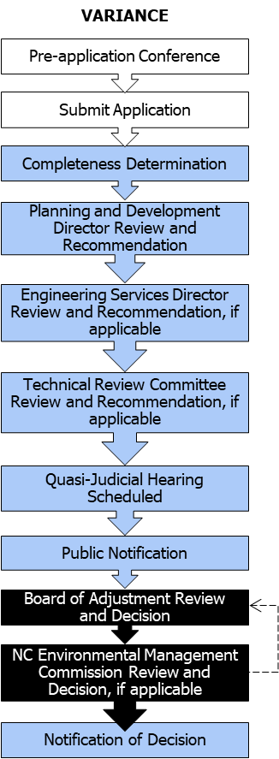

SECTION 3.
That Section 3.4.8.G., District Standards, related to the section reference of building standards within the Central Business District, is hereby amended as follows:
G. District Standards
1. Building Compliance due to Expansion or Exterior Alteration
(a) In cases where an existing building is expanded or enlarged by 25 percent or less of its gross floor area as it existed on June 5, 2017, or the effective date of the district upon the land, whichever is later, the expansion of the building shall either maintain the current appearance of the existing building or comply with the standards in Section 3.4.8 G.13, Building Standards.
(b) In cases where an existing building is expanded or enlarged by more than 25 percent of its gross floor area as it existed on June 5, 2017, or the effective date of the district upon the land, whichever is later, the portion of the front and side building facades associated with the expansion or enlargement shall comply with the standards in Section 3.4.8 G.13, Building Standards.

SECTION 4.
(Regarding sidewalk standards in the Mixed Use Districts and to renumber subsequent tables accordingly)

PART A.
That Section 3.5.7.C.2.h., Sidewalks, related to sidewalk widths within the Mixed Use District is hereby amended as follows, including the addition of Table 3.5.7.D. – Alternate Sidewalk Width Standards in the MX District:
(h) Sidewalks Sidewalks shall comply with the standards in Section 5.9, Sidewalks, as well as the following:
(1) Sidewalks shall be located on both sides of all streets except alleys.
(2) Sidewalks shall be located at the back of the curb and shall maintain a minimum width of at least 12 feet or up to the existing building line when less than 12 feet., unless an alternate width standard is provided in Table 3.5.7.D. – Alternate Sidewalk Width Standards in the MX District.

Author’s note: Table 3.5.7.D. – Alternate Sidewalk Width Standards in the MX District is established below as follows:

TABLE 3.5.7.D, ALTERNATE SIDEWALK WIDTH STANDARDS IN THE MX DISTRICT
Mixed-Use Downtown District (MX-D)
STREET NAME | WIDTH
Boulevard Street | 8 feet
Ferndale Avenue (W. of Lindsay Street) | 8 feet
Gatewood Avenue (W. of Lindsay Street) | 8 feet
Hayden Place | 8 feet
Lindsay Place | 8 feet
Oakwood Street | 8 feet
Virginia Place | 8 feet
W. Broad Avenue | 8 feet
Westwood Avenue (W. of Lindsay Street) | 8 feet
Mixed-Use Washington Street District (MX-W)
Fourth Street | 8 feet
Hobson Street | 8 feet
Richardson Avenue | 8 feet

(3) (unchanged)
(4) (unchanged)

PART B.
That the following table titles be amended to reflect the addition of Table 3.5.7.D. – Alternate Sidewalk Width Standards in the MX District.
TABLE 3.5.7.DE, DIMENSIONAL STANDARDS IN THE MX-W DISTRICT
TABLE 3.5.7.EF, DIMENSIONAL STANDARDS IN THE MX-D DISTRICT

PART C.
That Section 3.5.7.D.2., Dimensional Standards, be amended to reflect the addition of Table 3.5.7.D. – Alternate Sidewalk Width Standards in the MX District.

2. Dimensional Standards The dimensional standards in Table 3.5.7.DE, Dimensional Standards in the MX-W District, shall apply to all development in the MX-W District.

PART D.
That Section 3.5.7.E.2., Dimensional Standards, be amended to reflect the addition of Table 3.5.7.D. – Alternate Sidewalk Width Standards in the MX District.

2. Dimensional Standards The dimensional standards in Table 3.5.7.EF, Dimensional Standards in the MX-D District, shall apply to all development in the MX-D District.

SECTION 5.
(Regarding the description of a triplex/quadplex)

That Table 4.2.4. Residential Use Classification, to amend the use type description for a triplex/quadplex, is hereby amended as follows:

B. HOUSEHOLD LIVING | (h) Triplex/quadplex | A type of residential structure that includes 3 or 4 individual dwelling units located on 1 lot. or configured so that each unit is on its own individual lot.

SECTION 6.
(Regarding ground floor use standards for multi-family dwellings)

That Section 4.3.2.B.5., Multi-Family Dwelling, related to the use standards for multi-family dwellings, is hereby amended as follows to add ground floor use standards:
5. Multi-Family Dwelling Multi-family development shall comply with the following standards:
(a) through (g) (unchanged)
(h) Permitted Ground Floor Uses Along Main Street
(1) A minimum of 50 percent of the ground floor building frontage along Main Street shall be dedicated to institutional or commercial use types, or an active amenity which is commonly found within a multi-family dwelling, such as offices, recreation rooms, or common areas. The remainder of the frontage may be occupied by any use type permitted within the applicable zoning district.
(2) This standard shall only apply to multi-family dwellings with frontage on Main Street within the MS-A, MS-B, MS-C, MX-D and CB Districts.

SECTION 7.
Reserved

SECTION 8.
Should any section or provision of this ordinance be declared invalid, such decision shall not affect the validity of the remaining portions of this ordinance.

SECTION 9.
All ordinances or parts of ordinances in conflict with the provisions of this ordinance are hereby repealed.

SECTION 10.
This ordinance shall become effective upon adoption.

Adopted by the City Council
City of High Point, North Carolina
The 15th day of MAY, 2023
Sandra R. Keeney, City Clerk

By: _________________________________
Jay W. Wagner, Mayor
ATTEST:

___________________________________
Sandra R. Keeney, City Clerk

